***Digital flip clock***

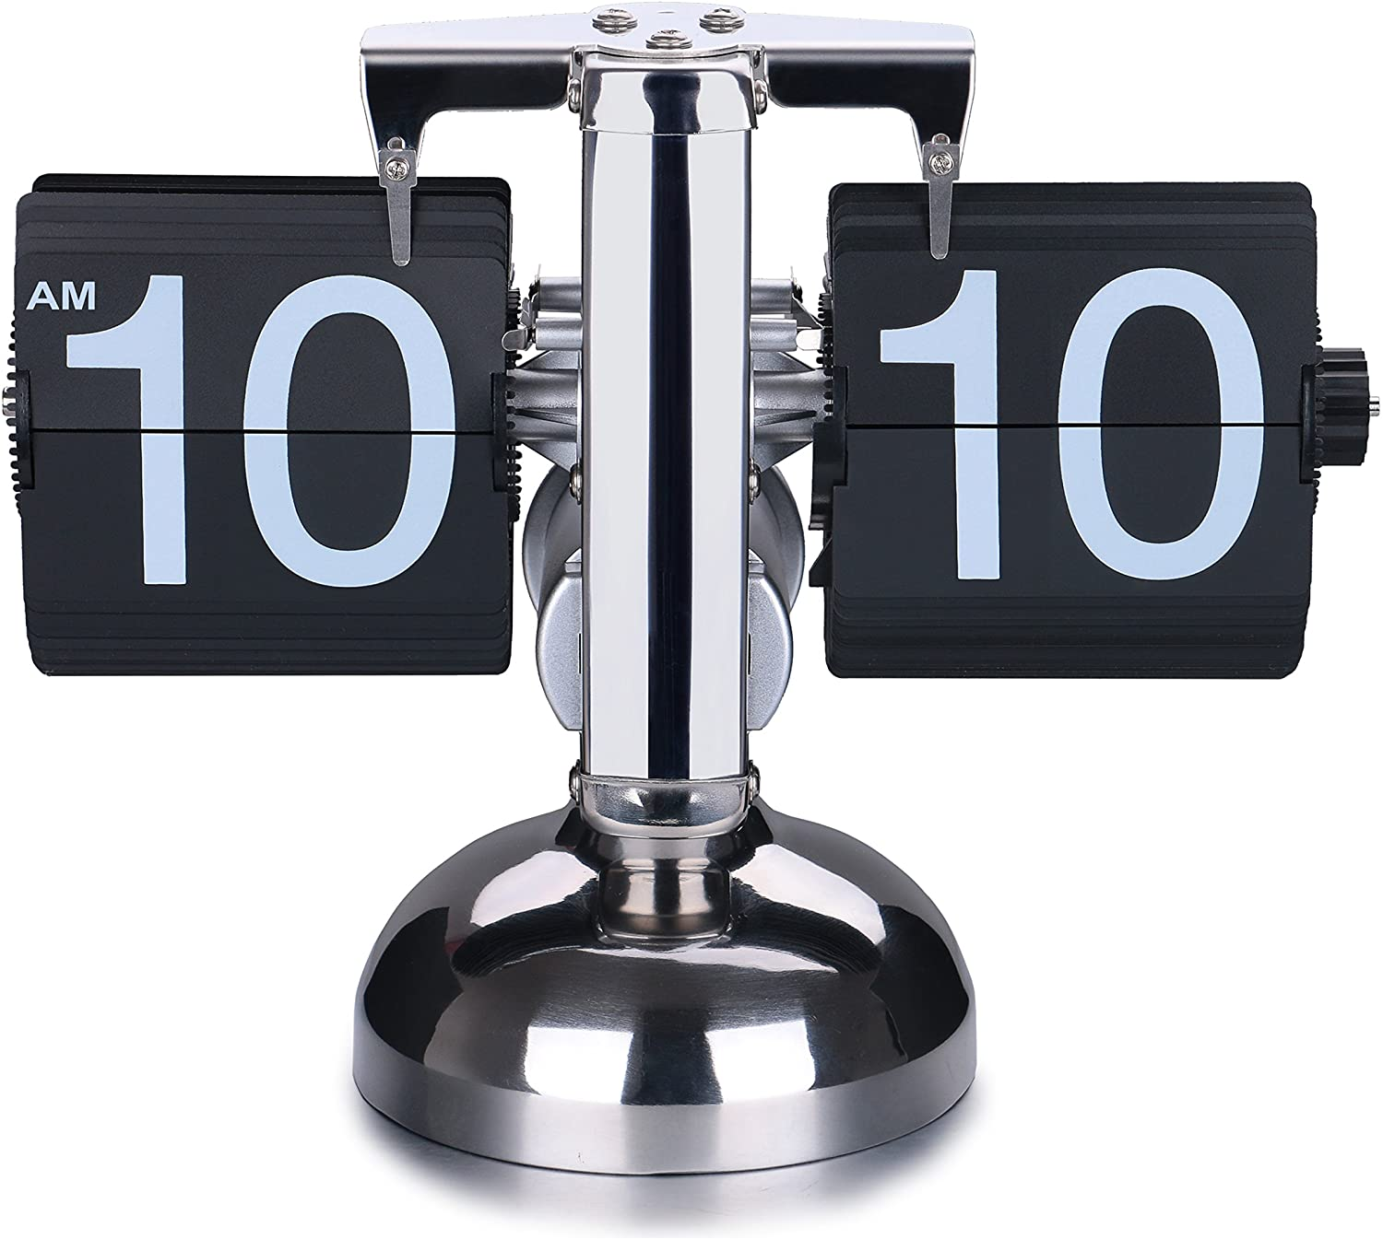

*The dial clock is made of stainless steel, Display 24h day and night mode. Take a look at the detailed product description below to better understand how the watch works. The product is very suitable as a gift for your boss, a gift for a customer or a partner, or as a gift for a boyfriend...*